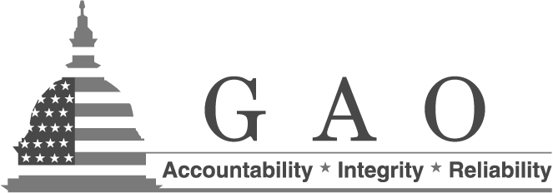
Why Giving Us Your Resume Is Not Enough:
Procedures and Tips for Successfully Navigating the GAO Application Process

We know you have a great resume, and that you have a lot to offer! We appreciate your interest in GAO and we want to hear from you. However, it takes more than having a great resume to be considered for a position at GAO.

As a part of the federal government, GAO follows merit system principles, which means that we must ensure that all job selections are based on candidates’ demonstrated knowledge and skills. We do this by reviewing all of the information presented in candidates application packages in light of specific job qualifications so that we can select those candidates best suited to perform the duties necessary for each position.

Please follow the application procedures below and consider the tips provided so you can put your best foot forward if you decide to apply to GAO.

Accessing the Vacancy and Application Information

- To search for GAO job opportunities, visit our external web site at www.gao.gov and click on the “Careers” tab (top right hand side of the screen).
- Next, click on the “Apply for Job” tab (left hand side of the screen).
- The screen that appears will instruct you to create a USAJOBS account, necessary for applying for any federal government position. Once you have an account you can instruct the USAJOBS system to email you every time GAO advertises a position. This is the best way to stay automatically informed of job opportunities with GAO.
- After creating a USAJOBS account or verifying that you already have one, return to the “Careers” section of GAO’s external web site and click “Browse Vacancies” (left hand side of the screen). You will be taken to a USAJOBS screen that is filtered for you and therefore shows only the GAO job opportunities that are currently available.
- Click on the title of a position and review the duties, the qualification requirements, the pay range and benefits associated with the position, etc. To apply, simply scroll to the bottom of the screen and click on the “Apply Online” tab (lower left hand corner of the screen).

Preparing a Thorough and Complete Application

- Review GAO’s external website www.gao.gov so that you are well-versed in the agency’s mission, organization, and work in general.
- Carefully read the job announcement so that you fully understand the duties of the position, the qualification requirements, and the application procedures.
- Answer all questions in the job announcement in a way that accurately portrays your knowledge, skills, and accomplishments, and whenever possible, use results-oriented examples to demonstrate how your work and/or educational experience addresses the competencies described in the job announcement.
- Make sure you have submitted all of the requested documentation. GAO can only consider complete application packages.
- Email or call the GAO point of contact listed on the job announcement if you have questions about the application process.

